BUSINESS RHYTHM: MEETINGS ARE NOT BAD – ALTHOUGH…
Poking fun at meetings is cannon fodder for cartoonists and workplace cynics. The successful streak of Dilbert hints at the popularity of the topic. The Dilbert Principle became a #1 New York Times Bestseller. But before doing away with meetings altogether, we need to acknowledge they’re often how we get work done. But how we can be more efficient / effective?
A recent Harvard Business Review (HBR) article identifies a path to free up time for meaningful work. Much has been written about this problem, but the solutions posed are usually discrete:
- Establish a clear agenda
- Hold your meeting standing up
- Delegate someone to attend in your place, and so on
HBR observed in their research and consulting that real improvement requires systemic change, because meetings affect how people collaborate and how they get their own work done. When probed into why people put up with the strain that meetings place on their time and sanity, HBR found something surprising: Those who resent and dread meetings the most also defend them as a “necessary evil” – sometimes with great passion.
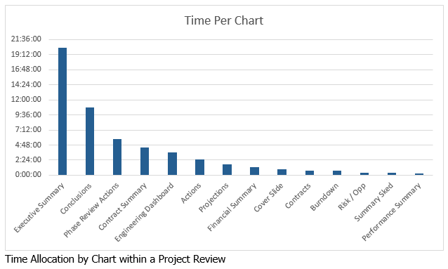Using a structured approach to analyzing and changing meeting patterns throughout your team or unit, you can make significant improvements.
According to HBR, groups escape the meeting trap by working together to follow five basic steps:
- Collect data from each person. Use surveys or interviews to gather data and impressions
- Interpret the data together. Come together as a team or a unit to digest everyone’s feedback and analyze what is working and what is not. Encourage open, nonjudgmental discussion.
- Agree on collective and personally relevant goals. Collective goals might include time savings, better data management, or accelerating a project. Personally relevant goals are finding ways to benefit individually from the group’s initiative and can be a great motivator. You could find ways to cover for one another and keep everyone updated to give individuals a needed break, while gaining a deeper understanding of your colleagues’ work, which can led to better-integrated offerings for customers.
- Set milestones and monitor progress.
As with any change effort, it is important that concrete and measurable progress be assessed and discussed along the way. Small, tangible wins provide something for people to celebrate, and small losses provide opportunities for learning and correction.
- Regularly debrief as a group.
Finally, HBR found that it is critical to regularly and openly take stock of how people feel about the meetings they attend and about their work process more generally. Frustration, resentment, and even hopelessness are signals that people are falling back into bad patterns. Moreover, changing protocols and behaviors takes time, and sustaining momentum requires consistent attention and contact.

